Celebrate Ganesh Chaturthi with Windows Apps

The ten-day period of celebration and worship of Lord Ganesh, affectionately called Ganpati, has begun with much festivity and zeal. Ganesh Chaturthi, one of the most sacred and spectacular festivals, honors the birth of the beloved Hindu elephant God, Lord Ganesh.
Here are some apps from Windows that will add more flavour and splendour to your celebrations!
- Ganesh Bhajan
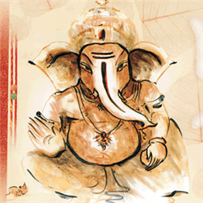

Immerse yourself in the festivities with the most popular devotional hymns or bhajans. This Windows app not only offers a wide range of hymns but also lets you decorate your home screen with stunning wallpapers of Lord Ganesh.

- Ganesh Runner
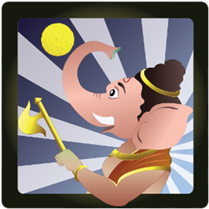

For all the Ganesh bhakts, Windows now offers a Lord Ganesh game primarily for reinforcing the true essence of Ganesh Chaturthi. The objective of the game is to help Lord Ganesh collect and eat as many laddoos as possible while dodging demons and obstacles!

- Zee Khana Khazana

We all know that Ganesh is a God who loves to eat. That is why, Ganesh Chaturthi recipes take on a special significance. Delicacies have always been one of the most essential highlights of any festivals in India. This Ganesh Chaturthi, let the Zee Khana Khazana app from the Windows store guide you to make some delicious dishes and Lord Ganesh’s personal favourites- laddoos and modhak.

- MapmyIndia Maps

With everyone celebrating the festival in Ganesh pandals and especially during Visarjan, navigating through the traffic roadblocks in the city can be quite a task. With the MapmyIndia Maps Windows app, you can get real time traffic updates and look for alternate routes to help you get around as quickly as possible.

- Lomogram+

There is never an experience that is complete without memories. This Ganesh Chaturthi, make sure that you get the nicest pictures of the pandals, the food spreads and especially the Visarjan with the Lomogram+ Windows app. With a number of filters, lighting effects and borders, the app makes editing pictures and sharing, easier than you thought. After all festivals are all about capturing those memories with friends and families and framing them. Digitally!
Throughout these ten days of festivities, pray to Lord Ganesh for inner spiritual strength and success. And for everything else, let these Windows app help you create an experience this Ganesh Chaturthi, like never before.

For more information, please contact:
Saranya Rustagi Nikita Verma
Microsoft Corporation India Pvt. Ltd. Edelman India
Email: srustagi@microsoft.com Email: Nikita.verma@edelman.com
Mobile: +91 9582808775 Mobile: +91 9810711548

